

**Artificial Intelligence and Data Science Department.**

OS / Even Sem 2021-22 / Experiment 10.

**___________________________________________________**

YASH SARANG.

47 / D6AD.

EXPERIMENT - 10.

Dynamic Partitioning.

**___________________________________________________**

**Aim:** Write a program to implement dynamic partitioning placement algorithms i.e Best Fit, First-Fit, Worst-Fit, etc.

**___________________________________________________**

**Theory:**

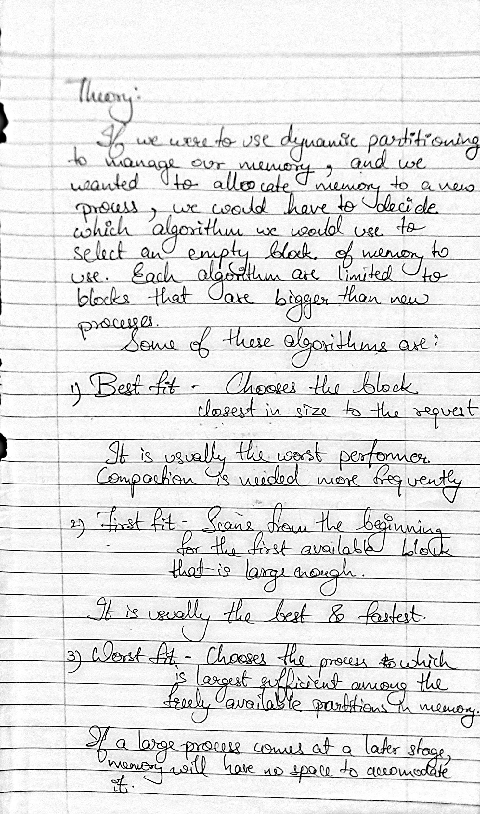

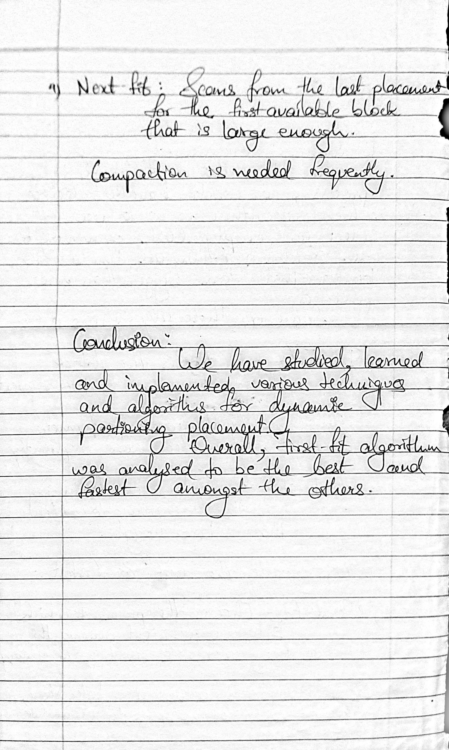

**___________________________________________________**

**Code:**

1. First Fit

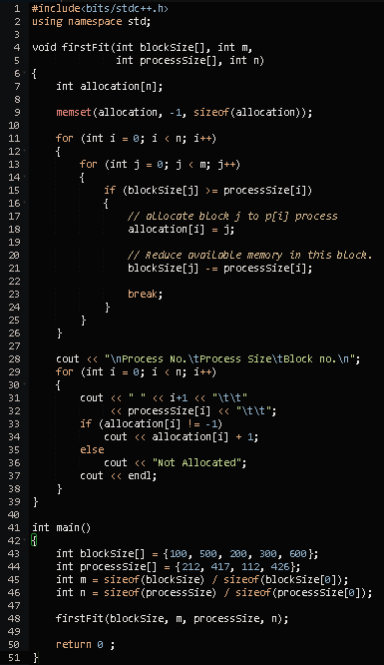

**Output:**

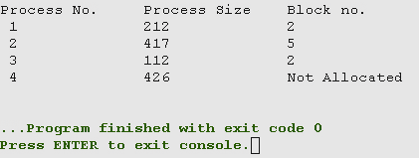

1. Best Fit

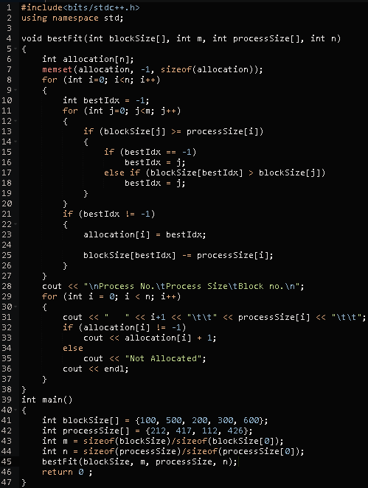

**Output:**

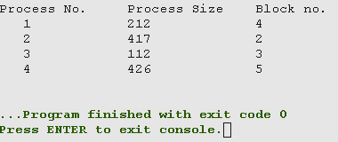

1. Worst Fit

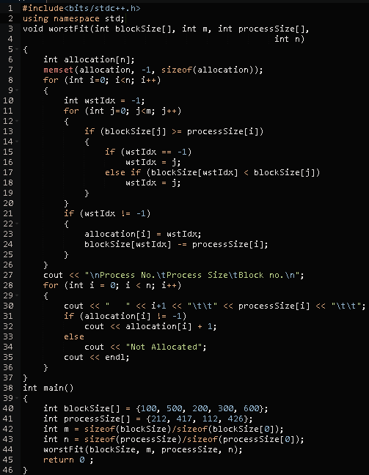

**Output:**

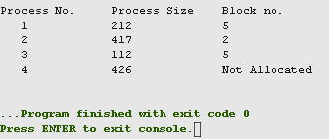

**___________________________________________________**

**Conclusion:-**



**___________________________________________________**